Bauer Core Standard Protocol
Title: Bioanalyzer High Sensitivity DNA Protocol
Pages: 6 | Revision: 1.0 | Date: 02/01/2012
Author(s): Jennifer Couget | Reviewers:
Contact: jcouget@cgr.harvard.edu | Comment:

1. Purpose

This protocol provides instructions for running DNA samples on the Agilent 2100 Bioanalyzer using the High Sensitivity DNA Protocol.

2. Materials

DNA samples (up to 11 per chip)
1 kb Plus Ladder (Invitrogen #10787-018)
Bioanalyzer DNA High Sensitivity Kit (Agilent #5067-4626) Includes chips and reagents.
Nuclease-free Water

3. Instrumentation
Agilent 2100 Bioanalyzer
Heat block (e.g. VWR standard)
Microcentrifuge (e.g. IEC Micromax RF)
Chip Priming Station (Agilent #5065-4401)
Vortexer (e.g. IKA model MS1)
Vortex Mixer Adapter (Agilent #5022-2190)

4. Reagent preparation

4.1. Combine Gel-Dye Mix (warm reagents to room temperature before use)
4.1.1. Add 7.5μl  Dye to 150μl  High Sensitivity DNA Gel Matrix in eppendorf tube. OR Add 15 μl  Dye to 300μl  High Sensitivity DNA Gel Matrix in eppendorf tube. 4.1.2. Vortex tube to mix. Pulse to spin down.
4.1.3. Transfer to spin filter.

4.2. Filtered Gel-Dye Mix (warm reagents to room temperature before use, 15 to 20 mins)
4.2.1. Add 157.5 μl or 315 μl of HS DNA Gel-Dye Mix to spin filter.
4.2.2. Spin for 10 minutes at 2300xg.
4.2.3. Remove column, and date tube.
4.2.4. Cover with tin foil when stored.
4.2.5. In subsequent assays, spin this tube for 10 minutes at max speed prior to each use.
4.2.6. Expires 4 to 6 weeks when stored at 4ºC.

4.3. 1 kb Plus Ladder
4.3.1. Provided at 5ng/μl, and use 1μl.
4.3.2. You will load 1kb Plus Ladder into the well next to your last sample.

4.4. Samples
4.4.1. Place at 37ºC for 1 to 2 minutes.
4.4.2. Load 1 μl per well of concentration 1ng/μl to 5 ng/μl.
4.4.3. Load samples in order from low concentration to high concentration.
5. Procedure

5.1. Preparing the Bioanalyzer
5.1.1. Ensure that an electrode is available (in the unit, the clean box, or the sonicator). As needed, place a clean Electrode into the Bioanalyzer Bayonet prior to use.
5.1.2 Load 350 μl nuclease-free H₂O into each of the H₂O Electrode Cleaning Chips.
5.1.3 Place cleaning chip into unit to rinse electrode for 30s-60s. Repeat twice.
5.1.4 Allow to air dry for 30s-60s.

5.2. Loading the Chip

5.2.1 Prepare the priming station for use (clean gasket, tighten syringe, position silver clip).
5.2.2. Pull the syringe to the 1ml mark.
5.2.3. Place the chip in the priming station.
5.2.4. Pipette 9μl of Gel-Dye mix into the well (G in a black circle).
5.2.5. Snap the priming station lid closed until you hear it click.
5.2.6. Push the plunger of the syringe down to 0.2 ml until it fits under the silver stopper.
5.2.7. Wait exactly 1 minute.
5.2.8. Squeeze the sliver stopper to release the plunger and let it rise to a complete stop.
5.2.9. Pull the plunger up the rest of the way to 1ml.
5.2.10. Gently lift the priming station lid.

Recommend: Inspect the back of the chip for any air bubbles before proceeding.
Air bubbles may appear in the area between the wells.
Area between the wells should be opaque / black.

5.2.11. Pipette 9μl of Gel-Dye mix into the other three G wells.
5.2.12. Pipette 5μl of the  HS DNA Marker into every sample well and ladder well.

Recommend: Pulse on vortexer as in step 5.2.16 to check well volumes.

5.2.13. Add 1μl of sample into each well.
5.2.14. Add 1μl of 1 kb PLUS ladder into the well next to the last sample.
5.2.15. Empty wells should be brought up to 6 μl using 1μl water.
5.2.16. Pipette 1μl of the ladder  into the ladder well.
5.2.17. Place the chip in the vortexer.
Set the dial to zero.
Turn the power on.
Turn the dial to 2200 rpm, such that the chip appears almost stationary.
Vortex the chip for 1 minute at about 2200 rpm.

** Be sure chip is correctly placed with  horizontal.
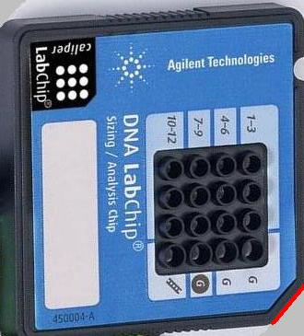← notched corner
5.3. Running the Chip

5.3.1. Open the Expert software.
5.3.2. Open the lid, and you should see an open lid on the screen.
5.3.3. Place the chip in the Bioanalyzer and gently close the lid.
You should see a chip appear on the screen.
5.3.3. Choose the Assay you wish to run

Assays → DNA → High Sensitivity DNA

5.3.4. Start
5.3.4.1 Enter the number of samples you are running.
5.3.4.2. Click Start.

5.3.5 Taskbar status
5.3.5.1 Script will download (approx. 1 minute).
5.3.5.2 Warming (4 seconds), Loading (20 seconds).
5.3.5.3 Focusing; monitor for 10 seconds.
Assay will return to previous states as the run proceeds.

If no errors after Focusing for 10 s, the run may be left unattended.
Assay time for a full chip is 30 minutes.

If errors occur, the run will abort and indicate the error in the upper right corner.
Check that you have done all steps correctly. See Section 5.5.

5.3.6 Assay Progression
5.3.5.1 The ladder will proceed first followed by well 1, 2, 3, 4, etc.
5.3.5.2 Traces will appear in real time on the screen.
5.3.5.3 Click “Data” on the left to view the traces that have completed.
5.3.5.4 Click “Data” on the left to enter the sample names.

5.4. Clean Up

5.4.1. Remove the chip from the Bioanalyzer promptly and discard.
5.4.2. Clean as for “Preparing the Bioanalyzer” in section 5.1.

An electrode may be re-used by rinsing between assays. You need 3 H₂O electrode cleaning chips to rinse the electrode. Fill each one with 350 μl of Nuclease-Free Water. Rinse 30s-60s per chip. Allow to air dry 30s-60s.

5.5. Notes and Tips for Best Results

5.5.1. Remove the chip soon after every run – do not let the sample dry on the electrodes!

5.5.2. Accurate pipetting is very important.
5.2.2.1. Use only the P2 and P10 properly calibrated pipets.
5.2.2.2. Use proper technique when dispensing.
5.2.2.3. Place the tip into the center and bottom of each well, staying perpendicular.
5.2.2.4. Push only to the first resistance point on the pipet to avoid bubbles.
5.2.2.5. You may pipet up and down gently to mix samples in the wells if needed.

5.5.3. Reagent care.
5.5.3.1. To protect the Gel-Dye mix from light, cover the tube with foil.
5.5.3.2. Remember to return the reagents to 4ºC when you are finished.
5.5.3.3. Be sure reagents are at room temperature and within the proper expiration dates.

5.5.4. Sample Prep.

5.5.4.1. Ideally, sample concentrations should be no more than 5 ng/μl.
Concentrations as low as 1 ng/μl may be used.
If your sample concentration is extremely low, you may load up to 2μl.
5.5.4.2. Each sample well must contain a total of 6μl.
5.5.4.3. You must put the  DNA Marker into every sample well and the ladder well.
5.5.4.4. Add water or  DNA Marker to unused wells for a final volume of 6μl per well.
5.5.4.5. Inspect the chip for sample splash after vortexing. If chip cannot be detected by
instrument, check that an electrode is properly installed into the bayonet and that
all wells have the proper volume. You may add additional  DNA Marker to the
wells in question.
5.5.4.6. Use the chip within 5 minutes of preparation to prevent evaporation.
Cover the chip with parafilm if it will be left standing for any length of time.
5.5.4.7. Genomic DNA contamination of DNA samples may produce stray bands or clog
the capillary.
5.5.4.8. Generally, chips with air bubbles in the capillaries will not result in a successful
assay. In this case, discard the chip and begin again.

5.5.5. Priming Station.

5.5.5.1. Press down slowly and steadily on the plunger when priming.
5.5.5.2. After releasing the plunger, it should rise to at least 0.3ml within 1-2s.
If it does not, check that the gasket is clean and retry.
If it still does not prime well, change the gasket (see staff for help).

5.5.6. Maintenance.

5.5.6.1. Electrodes must be cleaned daily using the method in section 5.1.
5.5.6.2. The focus lens should be cleaned monthly with isopropanol.
See staff if you suspect this is a problem.
5.5.6.3. The electrodes should be cleaned weekly by sonication.
See staff if you suspect this is a problem.

TROUBLE-SHOOTING YOUR ASSAY

- Are you using only the 2 μl and 10 μl Pipettes?

- Did you remember to check for air bubbles?

- Did you set up the priming station correctly?

  - clean / unclog the gasket with a wet KimWipe (di-H₂O) and dry KimWipe.
  - Silver Clip is in the correct position (Nano/Pico RNA top, HS DNA bottom)
  - Syringe securely attached to plate, verified by attempting to give a ¼ turn.
  - Syringe shows immediate rebound between 0.7 ml and 1 ml for Nano/Pico RNA; above 0.3 ml for DNA.

- Are you using the correct assay from the pull-down menu?

- Are your reagents freshly prepared and/or within the recommended using dates?

Filtered Gel: RNA (1 month),
Gel-dye Mix: RNA Nano (1 week), RNA Pico (24 hrs), DNA (4 to 6 weeks)

- Did you spin down for 10 mins Max Speed prior to loading your Gel-Dye Mix?

- Was there sample splash during vortexing? Check volumes under the light & adjust with a few μl’s of  marker as needed.

- Do all sample wells have 5 μl volume + 1 μl of sample or H₂O?

- Do any well volumes appear low? If so, add “ Marker” to make up the volume.

- Is the electrode CLEAN & DRY? Refer to the sign-out sheet for previous assay.

  - Clean electrodes may be found in the sonicator bath or in the box marked “Clean Electrodes”. Electrode & bayonet must be completely dry prior to use.

  - To dry, spray with 70% ethanol, pat dry with a KimWipe, and use N₂ gun on both sides (15s-30s per side, twice) to completely dry all crevices. If bayonet is wet, dry it, too. Turn off N₂ gun valve when you are done to avoid running tank dry.

  - An electrode may be re-used by rinsing between assays. You need 3 H₂O electrode cleaning chips to rinse the electrode. Fill each one with 350 μl of Nuclease-Free Water. Rinse 30s-60s per chip. Allow to air dry 30s-60s.

  - For DNA assay, please rinse as (c) between assays.

  - For RNA Nano assay, you may use the same clean electrode for multiple assays. Decontaminate with RNAse Zap, rinse with H₂O as (c), and allow to air dry per protocol.

  - For RNA Pico assay, a clean electrode is recommended after 2 assays. Decontaminate with RNAse Zap, rinse with H₂O as (c), and allow to air dry per protocol.

The template for each of the following assays is below. Please load your wells accordingly.

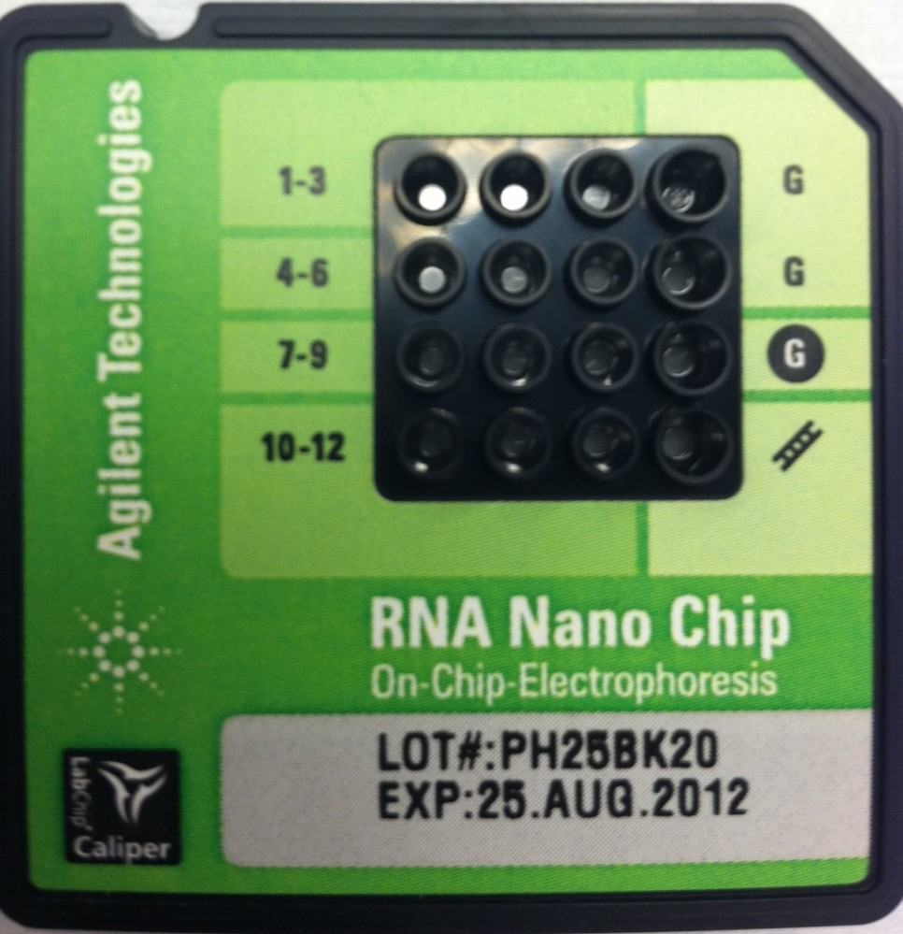

RNA Nano LabChip©

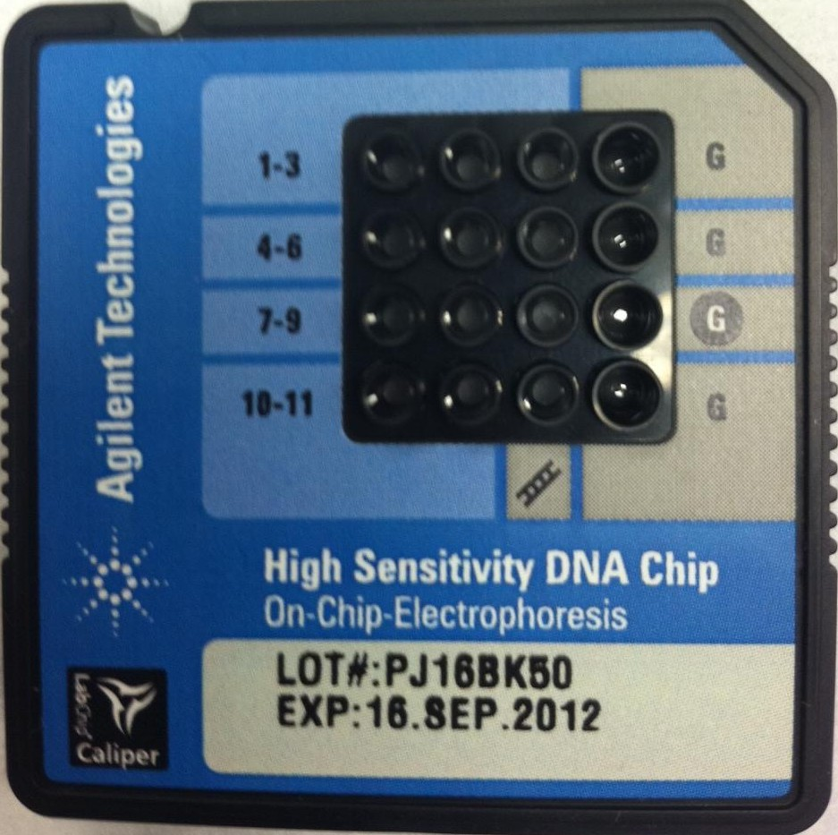

DNA High Sensitivity LabChip©

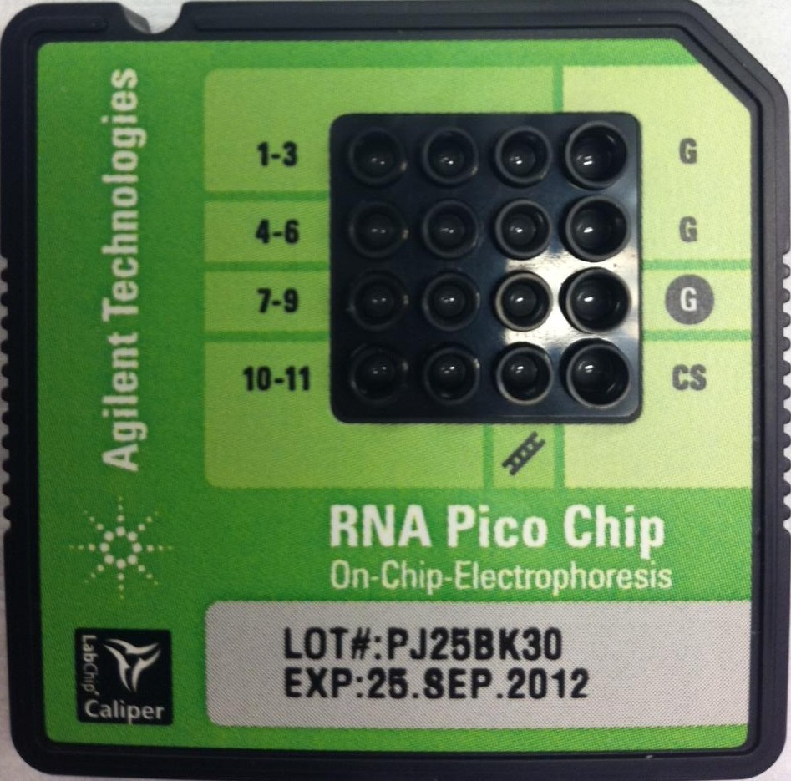

RNA Pico LabChip©

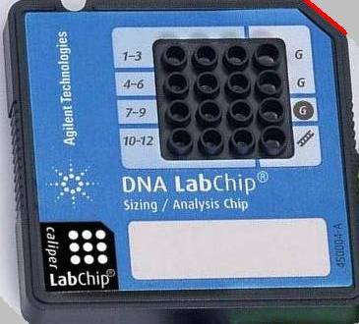

DNA 1000/7500/12000 LabChip©

